KHS 2nd Graders
Recommend…
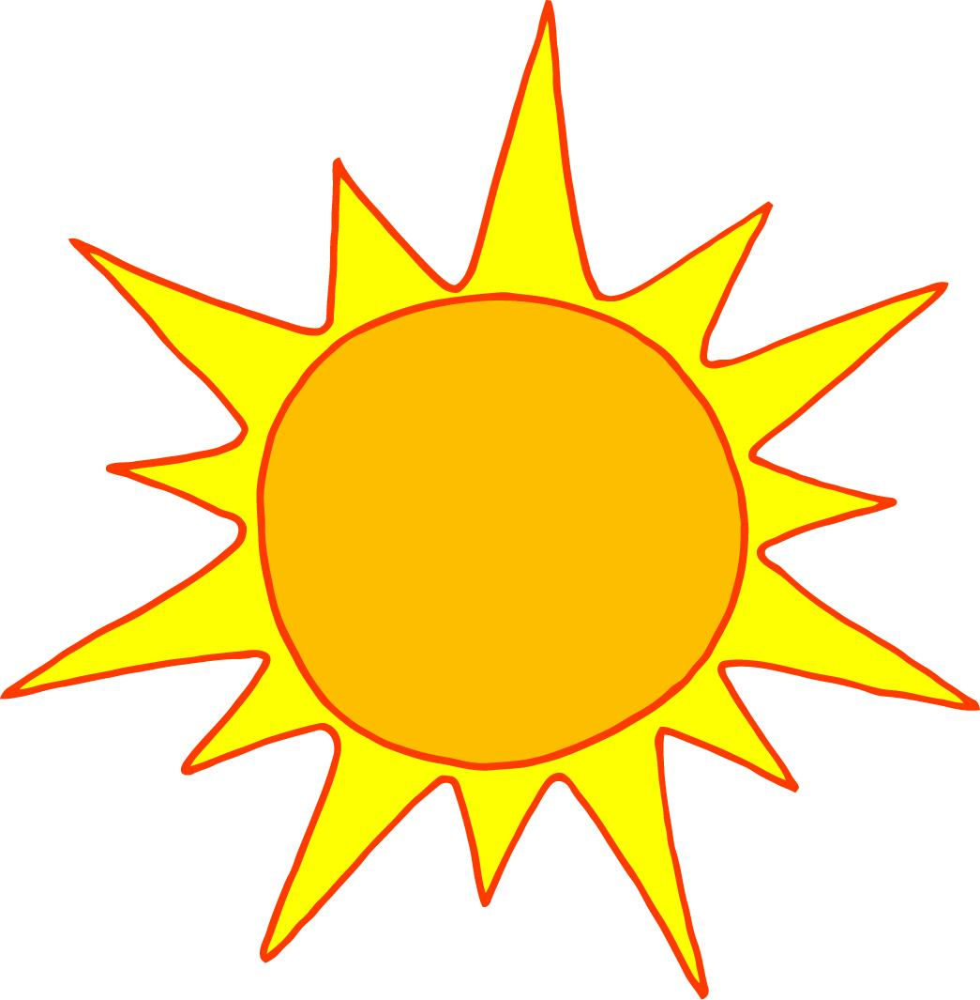
The I Survived Series by Lauren Tarshis
Notebook of Doom Series by Troy Cummings
The Stink Series by Megan McDonald
The Goosebumps Series by R.L. Stine
The Magic Treehouse Series by Mary Pope Osborne
The Bad Kitty Series by Nick Bruel
Babymouse series by Jennifer Holm
Dog Diaries series by Kate Klimo
Digby O’Day by Shirley Hughes
Spiderwick Chronicles by Tony DiTerlizzi

